October 3-7, 2011 Volume 6

Spelling Words
shovel, southern, northern, chapter, hyphen, chosen, establish, although, challenge, approach, astonish, python, shatter, ethnic, shiver, pharmacy, charity, china, attach, ostrich
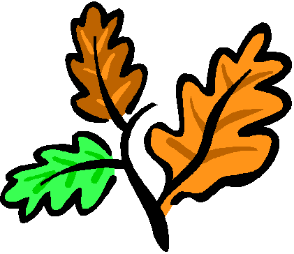

Reminders:

Open House is Tuesday, October 4 from 5:00-6:30. This will be a come and go time period. Remember this is a time for your children to show off what they have been doing in school. This would not be a time for a conference because of privacy issues. Please let us know, however, if you would like to set up a conference and we will set that up for another time. We hope to see everyone there!
- Don’t forget to get your number of checks signed in your agenda over the weekend!
- Our Website: www.teamfifth.weebly.com

Mrs. Dunnavant:

Reading – We will be reading Inside Out in the reading book this week. The vocabulary words are caterpillar, cocoon, disrespect, emerge, migrant, sketched, and unscrewed. Reading test on Friday. Students will also continue reading independently and writing in their writing journals. Students should complete a one page entry and add 4 vocabulary words to their journals by Friday.

Science – We will continue our Human Body Unit this week by studying the different body systems. This unit goes along with pages A32-A41 in the science textbook. The Human Body Unit Test is scheduled for November 9. Students should study their science notebooks nightly.

Language – We will continue to work on Narrative #1 – Biomes. Each day we will focus on a specific skill to make our writing better! We will write the final copy next week. DOL test on Friday.
Spelling – Creative spelling homework due Thursday. Spelling test on Friday.

Mrs. Crawford:
Math – We will continue Chapter 2, Multiplying Whole Numbers and Decimals, this week. Students will be working with variables, expressions and solving equations. Students need to make sure that all daily work from the chapter is completed in their math notebook. Look for the study guide to go home Friday, 10/7. The chapter test and notebook check will be the following week. The DOM test will be Friday. We will continue to take the Multiplication Speed Test this week. Once students make a 100/A+ on the speed test (100 facts) in three minutes, they will not have to continue to take the test. Students should practice their facts at home.
Social Studies – We are completing Chapter 2, The First Americans. All daily work should be kept in the student’s binder in the Social Studies section. The study guide will go home Monday. We will review Tuesday. The test will be Wednesday and the notebook will be due Thursday. Don’t forget that the next 4 students will present their Current Events project on Friday. Students can present their current events project earlier than their due date.
Language – We will complete Narrative #1 – Biomes. Monday we will finish revising and editing. Tuesday students will write their final copy. Narrative # 1 will be due on Wednesday. Then we will work with nouns in grammar.
Spelling - Creative spelling homework due Thursday. Spelling test will be on Friday.

