November 28- December 2, 2011 Volume 13

Reminders:

- We hope everyone has a blessed Thanksgiving holiday. We will see you back at school on Monday, November 28!

- Don’t forget to get your number of checks signed in your agenda over the weekend!

- Our Website: www.teamfifth.weebly.com

Spelling Words
waterproof, courthouse, lightweight, tablespoon, teaspoon, earthquake, fishhook, greenhouse, grasshopper, rowboat, spotlight, postcard, homesick, scrapbook, blindfold, hummingbird, barefoot, countryside, whirlpool, thumbtack
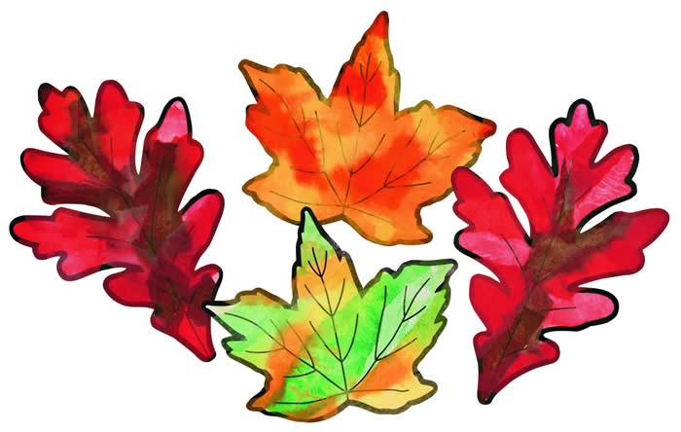
Mrs. Dunnavant:

Reading – We will read the story Leonardo’s Horse this week. Our vocabulary words are achieved, architect, bronze, cannon, depressed, fashioned, midst, philosopher, and rival. Students will also continue reading independently and writing in their writing journals. Students should complete a one page entry and add 4 vocabulary words to their journals by Friday.

Science – We will continue our Microworlds Unit this week with the study of cells and lenses. The at-home cell project is due December 13. Microworlds test on December 14. Students should study their science notebooks nightly.

Language – We will focus on past, present, and future verb tenses this week in grammar. DOL test on Friday.
Spelling – Creative Spelling Homework due Thursday. Spelling Test on Friday.

Mrs. Bradley:
Math – Students will divide with 2 digits in the divisor and 3-4 digits in the dividend.

Social Studies – We will work in Chapter 5 which is about the New England colonies. Students will name the original 13 colonies and identify them on a map.

Language – We will finish our study of verbs and have several review assignments which will count as a grade.

Spelling – Creative Spelling Homework due Thursday. Spelling Test on Friday.

