April 16-20, 2012 Volume 32
Spelling Words
famous, invention, election, furious, imagination, education, nervous, explanation, various, decision, relaxation, conversation, tension, humorous, exhibition, attraction, invasion, creation, occupation, destination
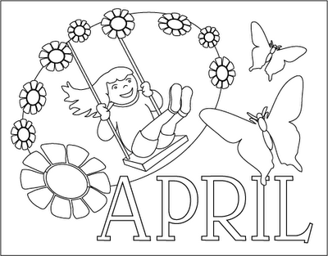

Reminders:

- Last week of testing! Tuesday, students will take Part 1 & 2 of Math. Wednesday, students will take Part 3 of Math and the Science Assessment. Please continue to make sure students arrive on time, get a good breakfast and are well-rested.
- Mark the calendar for Honor’s Day on May 23. Look for more information to come home soon.
- Don’t forget to sign your child’s agenda each Friday by the recorded number of checks for the week.

- Our Website: www.teamfifth.weebly.com

Mrs. Dunnavant:

Reading – We will begin reading Where the Red Fern Grows by Wilson Rawls this week. Students will be writing about what they read in their reading journals. Students will also need to find 4 vocabulary words from the book and add them to their reading journals this week.

Science – We will take the science portion of the ARMT + on Wednesday. Students have a study guide that includes everything that will be covered on the test. Students have been working on a second review packet that will be due on Thursday. Students should study their science notebooks nightly.

Language – Final copies of our persuasive writing pieces will be due on Thursday. We will begin our Zine projects this week. A Zine is a magazine based on one topic. Students will get a sheet outlining the project requirements. Zines will be due on May 18.
Spelling – Creative Spelling due Thursday. No test this week!

Mrs. Crawford:

Math – The time is finally here! We will have our math section of the ARMT + this week. The kids have worked so hard this year, and I know that they are ready! Monday, we will go over our ARMT + study guide that went home last week. Then on Tuesday, we will present our favorite project from Fraction Tic-Tac-Toe. Wednesday we will start line designs.

Social Studies – We will finish Chapter 11, A Growing Country. The notebook will be due on Thursday. We will not have a test for Chapter 11. The Chapter 11 Crossword will be due Tuesday, 4/23.

Language – In grammar, we will continue to focus on adverbs. We will also write in our WNBK. There will be a DOL test next week.

Spelling – Creative Spelling due Thursday. No test this week!

